**Lab 2**

**Name:-** Aryan Dilipbhai Langhanoja

**Date:-** 12-07-2023

**Enrollment No:-** 92200133030

**CO1: To write, test, and debug simple Python programs**

**CO2: To implement Python programs with conditional, loops and functions**

**Task 1:- Assigning the same value to a different variable at a time**

**Python Code:**

x = y = z = 99

print(x,y,z)

print(x)

print(y)

print(z)

**Output:**

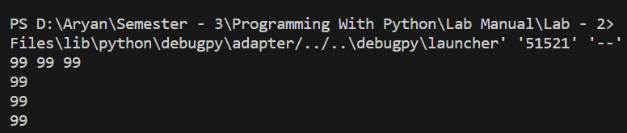

**Task 2:- Assigning the different value to a different variable at a time**

**Python Code:**

a,b,c = 5,6,7

print(a,b,c)

print(a)

print(b)

print(c)

**Output:**

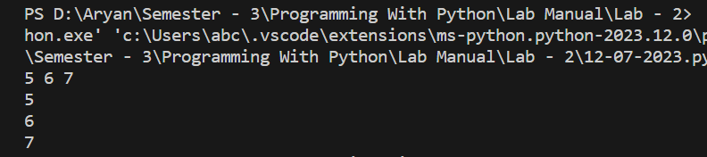

**Task 3:- Adding two numbers**

**Python Code:**

X = 10

Y = 20

print(X+Y)

**Output:**

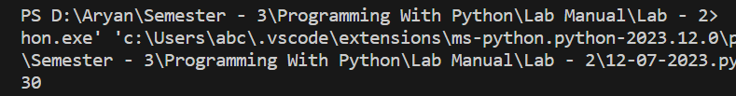

**Task 4:- Concating two strings**

**Python Code:**

P = "Hello"

Q = "World"

print(P + " " + Q)

**Output:**

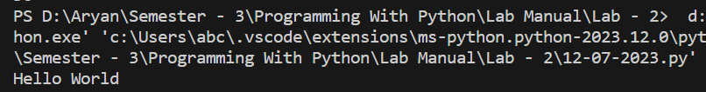

**Task 5:- Printing the string in different ways using indexing**

**Python Code:**

P = "Hello"

Q = "World"

R = P + " " + Q

print(R[:5])

print(R[::-1])

**Output:**

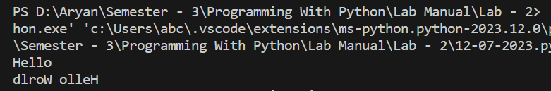

**Task 5:- implemet different operators on strings.**

**Python Code:**

H = "Aryan Langhanoja"

print(H[2:5])

print(H[:5])

print(H[2:])

print(H[::-1])

print(H[-1::])

print(H[::1])

print(H[1::])

print(H[::2])

print(H[-5:-2])

print('A' in H)

print('M' in H)

print(H*2)

T = "Aryan Langhanoja"

Q = "Aryan Patel"

print(T == Q)

print('A' in T)

print('A' not in Q)

**Output:**

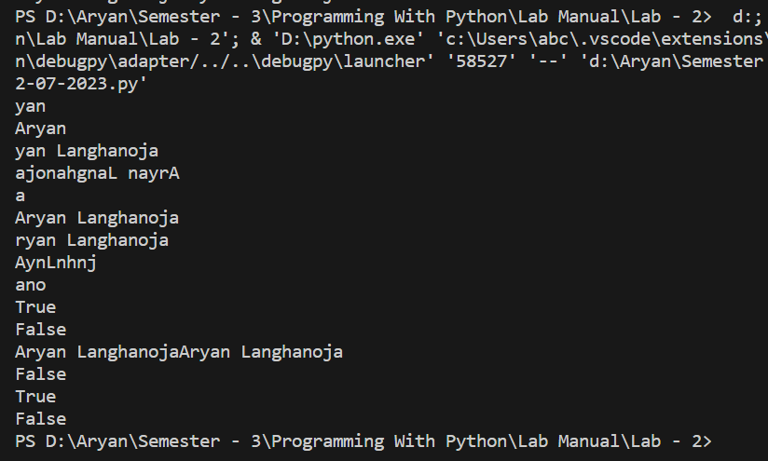

**Task 6:- implemet different operators on strings.**

**Python Code:**

name = "Aryan"

age = 19

marks = 20.39

string1 = 'Hey %s' % (name)

string2 = 'My Age Is %d' % (age)

string3 = 'Hello , My Name Is %s , My Age Is %d , And My Mark Is %f' %(name,age,marks)

print(string1)

print(string2)

print(string3)

**Output:**

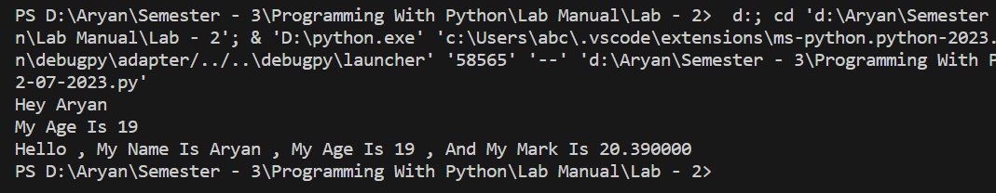

**Task 7:- implementing string methods**

**Python Code:**

x = "Aryan Langhanoja"

count = x.count('a')

title = x.title()

lower = x.lower()

upper = x.upper()

print(count)

print(title)

print(lower)

print(upper)

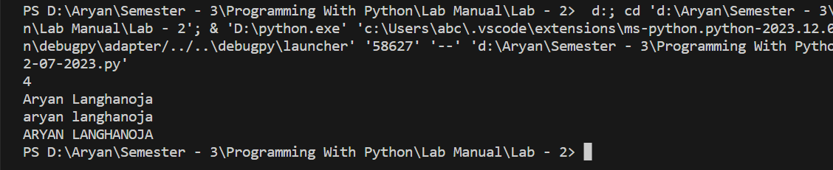**Output:**